## WHAT YOU NEED TO KNOW BEFORE YOU BEGIN YOUR RESEARCH REPORT

**Computer Science Department Bingham University**

## Postgraduate Research Report

A postgraduate report in the Computer Science Department, Bingham University presents the results of a postgraduate research investigation on a selected computing-related researchable topic. The report presents a researcher’s experience of proposing a solution through problem finding, data gathering, literature reviewing, methodology mapping, and development, implementing proposed solutions, results interpreting, and documenting information, summarizing and conclusions, and communicating facts after the conduct of approved research.

NOTE: All computing projects must present evidence of automation in solving the research problem. However, the supervisory team decides the weight for each level of study.

## Research reports are presented in four forms;

* + 1. Doctoral research as Thesis
    2. Academic Masters as Dissertations
    3. Professional masters and postgraduate diplomas as Research Projects
    4. Other research reports include thesis/Dissertation/project synopsis and seminar paper

## Specifications for Thesis/Dissertation/Project

An acceptable postgraduate research report must subscribe to the following specification

1. Research Title: A good research title should **adequately encapsulate** the essence of a

Thesis/dissertation/project using the fewest possible number of words. It should be a

**maximum of 20 words.**

1. **Paper Quality**: The paper used should **not be less than 75g/m²** and should adhere to

the A4 paper size **(8.27 inches x 11.69 inches).**

1. **Margins**: Ensure that the margins are set as follows: a left margin of **1.25 inches**, and

right, top, and bottom margins of **1.0 inches each**.

1. **Document Format:** Maintain a consistent format throughout the document. Utilize Times New Roman font with a **font size of 12**. For most of the content, maintain **double**

**line spacing**. However, the abstract and references sections should have **single-line**

**spacing**.

1. **Main Headings:** Use Times New Roman **font, size 14,** and apply center alignment and

bold formatting to your main headings.

1. **Other Headings:** Utilize Times New Roman font with a font size of 12 for

subheadings. Organize them using a multi-level numbering system as indicated in the

provided sample.

1. **Mathematical Notations and Equations:** Ensure that all mathematical notations, symbols, and equations are presented clearly and consistently. Maintain a cohesive style throughout the report. All equations must be numbered
2. **Language Style:** Write the report in British English. The use of American English or any other language variant is not permissible.
3. **Paragraphing:** Use block paragraphing, which means separating paragraphs with a single line space instead of using indentation.
4. **Pagination:** Begin with Roman numerals for preliminary pages (i ii, iii, iv …), and

conclude this style before Chapter One. Afterward, switch to Arabic numerals (1, 2, 3, 4…) for chapter numbering and the rest of the document.

1. **Figures, Tables, and Illustrative Drawings:** Assign self-explanatory captions to all figures, tables, and drawings. Number these elements according to the chapter in which

they appear (1.2, 2.2, 3.2, 4.4…). Adhere to the caption style guidelines of the

American Psychological Association (APA) 7th edition.

Figures refer to any images that are not presented in a tabular format.

Tables and figures may be integrated within the main body of your paper or presented on separate pages following your reference section. When placed on separate pages, tables precede figures.

Both tables and figures must include a designated table or figure number, a title, and a caption:

* + The number (e.g., Table 1 or Figure 1) should be positioned above the respective table or figure in the left margin, displayed in bold.
  + The title is situated one double-space below the table or figure number and is formatted in italics.
  + The caption is a descriptive text, double-spaced, and is located immediately below the table or figure.
  + The caption begins with the word "Note." in italics, followed by a description, source information, and copyright details at the end. Use "Adapted from" if you have modified the table or figure and "From" if you have reproduced it exactly as originally presented.

## Table 1

*The table title should be above aligned left*

|  |  |  |  |
| --- | --- | --- | --- |
| Head 1 | Head 2 | Head 3 | Head 4 |
|  |  |  |  |

*Note.* Description (if needed). Adapted from/From “Title of Article” by A. A. Author and A. A. Author, year, *Journal Title, volume*(issue), page number [(http://d](http://doi.org/10.xxxxxxx))o[i.org/10.xxxxxxx).](http://doi.org/10.xxxxxxx))

Copyright Year by Name of Copyright Holder.

## Figure 1

*Figure Title should appear above the figure. Figure should be place inside textbox*

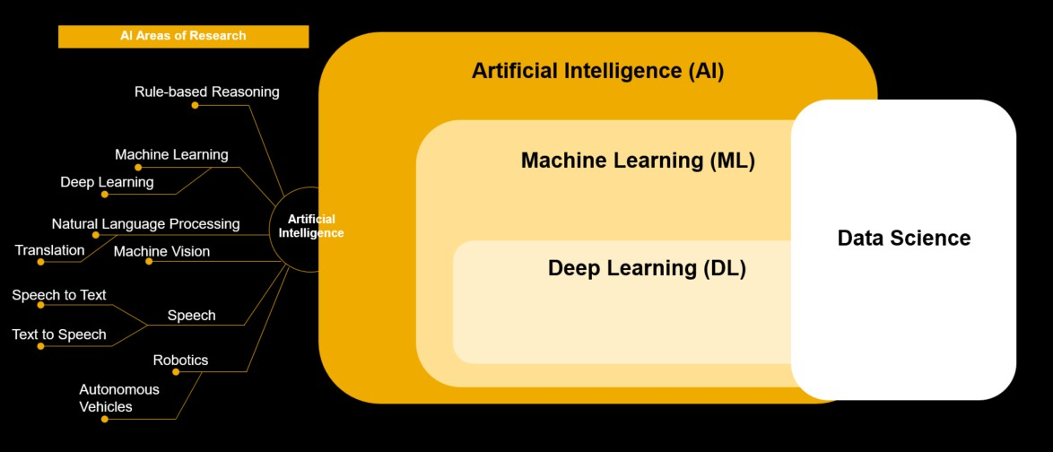

*Note.* Description (if needed). Adapted from/From “Title of Article” by A. A. Author and A. A. Author, year, *Journal Title, volume*(issue), page number [(http://d](http://doi.org/10.xxxxxxx))o[i.org/10.xxxxxxx).](http://doi.org/10.xxxxxxx))

Copyright Year by Name of Copyright Holder.

1. **Referencing Style:** Proper referencing is crucial to acknowledge the sources of materials used in your research report. Incorporate in-line citations within the body of the work to indicate referenced sources. Include a comprehensive reference list or bibliography at the end of the document, following the conclusion of Chapter Five. Ensure that there are at least 25 references for PGD and 35 references for Masters level work. Employ the referencing style of the American Psychological Association (APA) 7th Edition.

A. **In-Text Citations:** In your paper, use in-text citations to attribute information to your sources. There are two main types of in-text citations:

1. **Parenthetical In-Text Citation:** Place the author's last name and the publication year in parentheses at the end of the relevant sentence or paragraph. Example: You can use this like that (Smith, 2020)
2. **Narrative In-Text Citation:** Incorporate the author's name into the sentence itself, followed by the publication year in parentheses. Example: According to Smith (2020),...
3. You are encouraging citation tools like **Zotero, Mendeley, Citeulike, BibMe, RefWorks, and EndNote are** recommended for auto-referencing purposes.
4. **Referenceable Documents:** Utilize only reliable and verifiable sources for referencing purposes. These include published articles, books, and whitepapers. It is recommended to avoid referencing web pages and non-peer-reviewed publications, as they may not

provide the same level of credibility and accuracy.

1. **Main Body:** The main body structure might differ depending on the area and nature of research/work especially for chapters 3 and 4). The report for PGD must be between 10,000 and 20,000, and 15,000 to 30,000 for masters.

## Standard Organization Sequence:

**Cover Page Title Page**

## Declaration Page Certification Page Acknowledgment

All in single or 1.15-line spacing

**Abstract** (Maximum of 750/500/350 words for Thesis/Dissertation/Project)

**Table of content** (Should reflect only 1st, 2nd, and 3rd tier of headings)

## List of Figures List Cases/Stature

Double line spacing

## List of Plates List of Symbols

**List of Appendices List of Tables**

Optional

**Abbreviations, Definitions**, **Glossary** (All optional)

Chapter One: Introduction Chapter Two: Literature Review

Chapter Three: System Design and Methodology/Research Methodology Chapter Four: Implementation and Testing/Results and Discussion Chapter Five: Discussion, Summary, Conclusion and Recommendation References

Appendices (if any).

**A typical Thesis/Dissertation/Project report in the Department of Computer Science, Bingham University should have the following as a minimum working template**

# COVER PAGE

TITLE OF THESIS/DISSERTATION/PROJECT

BY

FULL NAME (SURNAME FIRST) [REGISTRATION NUMBER]

(DEGREE)

Ph.D. COMPUTER SCIENCE

M. Sc. COMPUTER SCIENCE

M. CYBERSECURITY AND DIGITAL FORENSICS PGD COMPUTER SCIENCE

(DATE) NOVEMBER, 2023

# TITLE PAGE

TITLE OF THESIS/DISSERTATION/PROJECT

BY

FULL NAME (SURNAME FIRST) REGISTRATION NUMBER

A THESIS/DISSERTATION/PROJECT SUBMITTED TO THE SCHOOL OF POSTGRADUATE STUDIES, BINGHAM UNIVERSITY, KARU, NASARAWA STATE, NIGERIA

IN PARTIAL FULFILMENT OF THE REQUIREMENT FOR THE AWRD OF

………………..,,,,,,,,,,,,,,,,,,,,,, (Ph.D./M.Sc.PGD) DEGREE IN COMPUTER SCIENCE. MONTH YEAR *(02/2022)*

DEPARTMENT OF COMPUTER SCIENCE FACULTY OF COMPUTING

BINGHAM UNIVERSITY, KARU NIGERIA

(DATE) NOVEMBER, 2023

# DECLARATION

I hereby declare that this Thesis/Dissertation/Project entitled [STATE TITLE] has been performed by me in the Department of Computer Science, Bingham University Karu, under the supervision of **(**STATE NAMES OF SUPERVISORS**).** The information derived from the literature has been duly acknowledged in the text and a list of references provided. No part of this project Thesis/Dissertation/Project was previously presented for another degree or diploma at this or any other institution.

Author’s Name (Surname first) ……………………… …………….

Signature Date

# CERTIFICATION

This thesis/Dissertation/Project titled, (STATE TITLE) by (State Your Name with Surname first in caps), (state your matriculation number) meets the regulations governing the award of the degree of (state degree/diploma) of Bingham University, Karu and is approved by the Project/Thesis/Dissertation Examination Committee for its contribution to knowledge and literary presentations.

State name of first supervisor Date

Chairman, Supervisory Committee

State name of second supervisor Date

Member, Supervisory Committee

State name of PG rep Date

Internal Examiner

State name of HOD Date

Head of Department (HOD)

State name Date

Chairman of Committee

State name of dean of PG school Date

Dean, School of Postgraduate Studies

# ACKNOWLEDGEMENT

Express gratitude to individuals that provided one form of assistance or the other

# ABSTRACT

*The abstract is a concise summary of your work, presented as a single paragraph. It should range from 200 to 350 words. Within this paragraph, include the definition of the topic, a clear outline of the problem you're addressing, the methodology you employed, your implementation or results, key findings, and any recommendations. The abstract serves as a guide for the reader to decide whether to continue reading, based on their interests and ongoing research. Set the abstract in italics, using single line spacing and a font size of 12. Remember that it's the last preliminary page before the main body of your document.*

# TABLE OF CONTENTS

COVER PAGE i

TITLE PAGE ii

DECLARATION iii

CERTIFICATION iv

ACKNOWLEDGEMENT v

ABSTRACT vi

TABLE OF CONTENTS vii

CHAPTER ONE 1

INTRODUCTION 1

* 1. Background of Study 1
  2. Statement of Problem 1
  3. Research Question 2
  4. Aim and Objectives 2
  5. Significance of the Study 2
  6. Scope of study 3
  7. Organization of the study 3

Chapter One – Summarize your sections in Chapter One 3

Chapter Two– Summarize your sections in Chapter Two… 3

Chapter Three – Summarize your sections in Chapter Three 3

Chapter Four – Summarize your sections in Chapter Four… 3

Chapter Five – Summarize your sections in Chapter Five 3

CHAPTER TWO 4

LITERATURE REVIEW 4

* 1. Introduction to the Research Topic 4
  2. Historical Context of the Research Topic 4
  3. Key Concepts and Definitions 6
  4. Review of Related Literature 6
  5. Methodologies and Research Designs 6
  6. Empirical Studies 7
  7. Conceptual Frameworks 7
  8. Debates and Controversies 7
  9. Theoretical Contributions 7
  10. Methodological Contributions 8
  11. Practical Implications 8
  12. Regional or Contextual Variations 8
  13. Related Works (Minimum 15 reviewed journals related to your topic) 8

CHAPTER THREE 9

SYSTEM DESIGN AND METHODOLOGY/RESEARCH METHODOLOGY 9

* 1. Research Approach 9
  2. Research Questions and Hypotheses 9
  3. Research Design: 9
  4. Software Development Methodology 10
  5. Data Collection Methods 10

3.6. Ethical Considerations 10

* 1. Tools and Software 10
  2. Research Timeline 11

3.11. Data Presentation: 11

3.12 Research Methodology for Software Development 11

CHAPTER FOUR 14

IMPLEMENTATION AND TESTING/ RESULTS AND DISCUSSION 14

* 1. Implementation 14
     1. Database Implementation 15
  2. Testing 15
     1. Unit Testing 16

4.5 Results Presentation 18

4.3 System Performance Evaluation 19

4.6 Discussion 19

CHAPTER FIVE 20

SUMMARY, CONCLUSION RECOMMENDATION 20

* 1. Summary 20
  2. Conclusion 20
  3. Recommendation 20

REFERENCES 21

APPENDIX A 24

**CHAPTER ONE** **INTRODUCTION**

## Background of Study

* + 1. Discuss the general area of your study in relation (one paragraph)
    2. Narrow the issue to what you are trying to tackle (one paragraph)
    3. State the emerging concern in the area of your research (one paragraph)
    4. State what has been done so far in the literature in the area of research (one paragraph)
    5. State the impact of the outcome to the study (one paragraph)

## Statement of Problem

`

* What – What is the problem? Quote facts and figures with relevant references. And, what are the causes of the problem?
* Why – Why is it a problem? (What impact does it have on the environment, life, property, organizations, and society?)
* When - When does the problem occur? (Periods, duration etc)
* Where - Where is the problem occurring? (locations, processes, products, etc).
* Who - Who does the problem affect (Specific groups, organizations, customers, etc. Who needs the solution)?
* How - Research Question - How do we solve the problem?
* What are the existing solutions to the problem (if any), and their limitations (what you think will add value or improve on the existing study but has not been done by others in the area of research)? What gap is this study seeking to fill (which of the limitations do you intend to handle in your study)?
* Propose a solution or hypothesis to the research question (optional).
* What are the principles and theories behind the proposed solution?

## Research Question

The Research Question – this is where the Researcher presents the question that will indicate the gap revealed by the literature to be a missing piece in the topic’s area of research. The Research Question may be expressed as either an actual question or a declarative statement. The research question may be followed by either a hint of the method to find a solution to the gap, or a hypothesis, or the main purpose of the study.

## Aim and Objectives

Once you have formulated a clear problem statement or core research question reflecting the main goal or purpose of your study, it is time to consider the more specific research objectives that you want to achieve.

Achieving your research objectives should lead you to solve **the main research problem or answer the core research question.** One of your objectives may be to test specific hypotheses, while others may relate to the gathering of descriptive data or to the development of a conceptual framework based on available literature. You should consider the following guidelines when drafting research objectives:

Research objectives must be presented with quantifiable verbs and list, it should be phrased in the form:

1. “To design …”,
2. “To implement …”,
3. “To integrate …”,
4. “To determine …”,
5. “To investigate …”,
6. “To evaluate …”,
7. “To compare …”

## Significance of the Study

This section should elaborate on why your study is important and also deliberate on the impact of your study in society.

## Scope of study

## Organization of the study

Chapter One – Summarize your sections in Chapter One………………

Chapter Two– Summarize your sections in Chapter Two………………

Chapter Three – Summarize your sections in Chapter Three………………

Chapter Four – Summarize your sections in Chapter Four………………

Chapter Five – Summarize your sections in Chapter Five………………

# CHAPTER TWO LITERATURE REVIEW

A literature review in a Thesis/dissertation/Project is a critical and comprehensive examination of the existing research and scholarly literature relevant to your research topic or question. It serves several important purposes within your Thesis/dissertation/Project; This should be a concise report about the studies of others on the subject matter. It should be logically arranged and up to date. A significant number of the references (> 70%) should be within the preceding 5 years.

## Introduction to the Research Topic

A paragraph that provides an overview of the research area. Explain the significance and relevance of your research.

State your research questions or objectives.

## Historical Context of the Research Topic

Discuss the historical development of research in your research area/topic. Identify key milestones, studies, or foundational theories related to your work.

The cybersecurity theoretical framework provides a conceptual basis for analyzing and addressing cybersecurity challenges.

* + 1. Present the theoretical framework or theoretical perspectives that underpin your study.
    2. Explain how previous research has contributed to the development of the theoretical framework you are using

The following are some key theoretical frameworks and models in cybersecurity that may concern your work.

## YOU MAY HAVE TO DISCUSS IN DETAIL ONLY THE THEORETICAL FRAMEWORKS THAT CONCERN YOUR WORK. THE FEWER THE BETTER

1. CIA Triad: The CIA Triad is a fundamental framework that represents the core principles of cybersecurity:
2. Defense-in-Depth: This model emphasizes the use of multiple layers of security controls to protect systems and data. It includes network security, access controls, encryption, intrusion detection, and more.
3. Zero Trust Security: Zero Trust is a model that assumes no entity, whether inside or outside the organization, can be trusted by default. It requires continuous authentication and authorization for all users and devices.
4. NIST Cybersecurity Framework: Developed by the National Institute of Standards and Technology (NIST), this framework provides guidelines for organizations to manage and reduce cybersecurity risk. It consists of five core functions: Identify, Protect, Detect, Respond, and Recover.
5. Kill Chain Model: This model, often used in the context of threat analysis, describes the stages of a cyberattack from the initial reconnaissance to the final exfiltration of data. Understanding the kill chain can help organizations identify and mitigate threats at various stages.
6. Deterrence Theory: Borrowed from the field of international relations, deterrence theory applies to cybersecurity by suggesting that the threat of retaliation or punishment can deter cyber adversaries from attacking.
7. Rational Choice Theory: This psychological and behavioral theory explores the decision- making processes of cybercriminals, seeking to understand their motivations and incentives.
8. Cyber Resilience Framework: Cyber resilience focuses on an organization's ability to withstand and recover from cyberattacks. This framework includes strategies for incident response, business continuity, and disaster recovery.
9. Information Security Risk Management Frameworks: Various frameworks, such as ISO 27001, provide structured approaches to identifying, assessing, and managing information security risks.

## Key Concepts and Definitions

Define and clarify key concepts and terms relevant to your research **WITH CITATIONS**. Ensure a common understanding of terminology among readers.

## Review of Related Literature

Summarize and discuss previous studies, articles, books, and research related to your research topic, citations are mandatory. Organize this section **THEMATICALLY** or **CHRONOLOGICALLY**. Pick one and stick to it.

## Methodologies and Research Designs

Discuss the **research methods and methodologies** used in previous studies related to your topic **WITH CITATIONS**. Evaluate the strengths and weaknesses of these methods.

## Empirical Studies

Empirical reviews are important because they provide evidence-based insights and contribute to the body of knowledge in a particular field. Here are some key characteristics and examples of empirical reviews.

Present the findings of empirical studies that are closely related to your research questions. Discuss the methodologies and key results of these studies **with CITATIONS.**

## Conceptual Frameworks

Discuss existing conceptual frameworks or models that inform your research. Explain how these frameworks have been applied in previous research. A conceptual framework is a critical component that provides a structured and organized foundation for understanding, analyzing, and interpreting the research problem or question. It is a theoretical structure that outlines the key concepts, variables, relationships, and theories relevant to the study.

The purpose of a conceptual framework is to guide the research process, connect the research to existing knowledge, and help the researcher develop hypotheses or research questions.

## Debates and Controversies

Explore any ongoing debates, controversies, or disagreements within the literature. Present different viewpoints or schools of thought.

Identify gaps in the existing literature that your research aims to address. Discuss the limitations of previous studies and how your research will address them.

## Theoretical Contributions

Discuss how your research will contribute to and advance the theoretical framework of the

field.

## Methodological Contributions

Explain how your research will contribute to methodological advancements in the field.

## Practical Implications

Discuss the practical implications of previous research for real-world applications or policy. Explain how your research may have practical significance.

## Regional or Contextual Variations

If applicable, discuss how research findings vary across different regions, contexts, or populations.

## Related Works (Minimum 15 reviewed journals related to your topic) Table 2

*Example of Empirical Analysis of related work*

|  |  |  |  |  |  |
| --- | --- | --- | --- | --- | --- |
| **S/N** | **Name** | **Title** | **Method** | **Findings** | **Limitation** |
| 1 | Meweda et al.,  (2020) | Spectral-spatial features integrated convolution neural network for Breast cancer classification | Spectral-spatial features introduced in CNN, Random 70/30 | Max acc  = 97% (40X) | Requires computing resource |
| 2 | Lie et al.,  (2020) | Shallow Convolutional Neural Network for Image classification | Batch normalization dropout. 80/30 | Max acc  = 97% (100X) | high resource utilization. |
| 3 | Hao et | Breast cancer | deep semantic | Max acc | Requires |
|  | al., | histopathological image | features and | = 96.7%, | computing |
|  | (2022) | classification based on | gray level co- | (40X) | resources. |
|  |  | deep semantic features | occurrence |  |  |
|  |  | and gray level co- | matrix |  |  |
|  |  | occurrence matrix | 70/30 |  |  |

# CHAPTER THREE

# SYSTEM DESIGN AND METHODOLOGY/RESEARCH METHODOLOGY

Research methodology outlines the systematic process you will follow to conduct research, gather data, analyze findings, and draw conclusions. Note that the specific methodology for your Thesis/dissertation/Project will depend on your research questions, objectives, and the nature of your research. It's essential to follow ethical guidelines and choose appropriate methods to ensure the validity and rigor of your research. Below is an overview of the research methodology for a Thesis/Dissertation/Project dissertation.

## Research Approach

Quantitative, Qualitative, or Mixed Methods: Decide on the research approach you will use. Cybersecurity research can involve quantitative methods (e.g., surveys, data analysis), qualitative methods (e.g., interviews, case studies), or a combination of both.

## Research Questions and Hypotheses

Formulate clear and specific research questions or hypotheses related to you research topic. Your research questions should guide your data collection and analysis.

## Research Design:

Choose a research design that aligns with your project's goals. Common options include:

**Experimental:** If your project involves testing the effectiveness of new algorithms or technologies.

**Descriptive:** If your project focuses on documenting existing software systems or practices.

**Exploratory:** If your project aims to understand and discover new aspects of software development.

## Software Development Methodology

Select a software development methodology that suits your project. Common methodologies include Agile, Waterfall, Scrum, and DevOps. **EXPLAIN HOW YOU WILL ADAPT THE CHOSEN METHODOLOGY TO YOUR SPECIFIC RESEARCH GOALS.**

## Data Collection Methods

**Surveys:** If you're conducting surveys, explain how you will design the questionnaire, select participants, and administer surveys. Discuss any ethical considerations.

**Interviews:** If interviews are part of your methodology, describe your interview protocol, sampling strategy, and how you will transcribe and analyze the interviews.

**Data Analysis:** Detail how you will analyze the data, whether through statistical software, content analysis, or other methods.

**Secondary Data:** Explain if you will use existing datasets, logs, or reports and how you will access and analyze this data.

## 3.6. Ethical Considerations:

Discuss ethical concerns related to research interest, including participant privacy, informed consent, and data security. Explain how you will address these issues.

## Tools and Software:

Specify any tools, software, or frameworks you will use in your research, such as network monitoring tools, data analysis software, or simulation platforms.

## Research Timeline

Create a timeline that outlines the various phases of your research, from data collection to analysis and writing. Set realistic deadlines for each phase.

## Data Analysis/Evaluation Plan:

Provide a detailed plan for data analysis, including the statistical or qualitative techniques you will use to answer your research questions or test hypotheses.

## Validity and Reliability:

Discuss how you will ensure the validity and reliability of your research findings. For quantitative research, this might involve discussing measures for data validity and reliability. For qualitative research, explain steps to ensure trustworthiness and credibility.

## Data Presentation:

Describe how you will present your research findings, including the use of tables, charts, and visual representations.

## Research Methodology for Software Development

Research methodology for a software development project involves defining a structured approach to guide the development process and answer research questions or achieve project objectives. Below is a general research methodology framework for a software development project:

## 1. Project Objectives and Research Questions:

Clearly state the objectives of your software development project. What are you trying to

## Data Analysis:

Specify the data analysis techniques you will use to answer your research questions or assess project outcomes.

For qualitative data, this may include content analysis or thematic coding. For quantitative data, outline statistical analysis methods.

## Software Metrics (if applicable):

Define the software metrics you will collect and analyze to assess software quality, performance, or other relevant factors. Explain how these metrics relate to your research questions.

## Development Process:

Detail the steps of the software development process, including requirements gathering, design, implementation, testing, and deployment. Describe any variations or customizations to the standard development process based on your research needs.

## Evaluation Criteria:

Define the criteria or benchmarks against which you will evaluate the success or effectiveness of the software development project. Explain how these criteria align with your research objectives.

## Ethical Considerations

Discuss ethical concerns related to your research, including participant privacy, informed consent, and data security. - Outline the steps you will take to address these ethical considerations.

## For those working on software development projects, you can use the following

methodology

* + 1. System Design and Methodology
    2. Review of Methodologies (Review at least 4)
    3. Adopted/Adapted Methodology (Discuss the one you picked and why)
    4. System Architecture/Workflow for machine learning project/thesis/dissertator
    5. System Modelling (Use at least 3 UML diagrams to model your software [use case diagram, activity diagram, DFD diagram, sequence diagram, class diagram, etc.])
    6. System Requirements (functional and non-functional requirements) The use of MoSCoW priorities is highly recommended.

3.11.7. Interface Design

3.11.8 Database schema design

# CHAPTER FOUR

# IMPLEMENTATION AND TESTING/ RESULTS AND DISCUSSION

This chapter presents the output of you work. It is majorly dependent on the design and methodology stage. The artefact of all the work done is fully explained

1. A new application
2. Results of simulations done
3. Statistical approaches
4. Modelling (Machine Learning, Deep Learning, persona etc.)

The acceptance, strength and effect of proposed output is presented here. This part is fully your work so no reference except for evaluation and discussion purpose. It is made up of screenshots, figures, tables, relevant illustrations, data presentation (sometimes), data analysis (sometimes) This chapter presents the research findings.

## Implementation

The acceptance, strength and effect of proposed output is presented here. This part is fully your work so no reference except for evaluation and discussion purpose. It is made up of screenshots, figures, tables, relevant illustrations, data presentation (sometimes), data analysis (sometimes). This chapter presents the research findings

After each diagram there must be enough explanation. Special functions can be presented and explained using code snippets. Someone else should be able to pick your work and understand it fully this should include: Being able to Navigate through your product or artefact. Identify all the features with understanding of how they work,

## Database Implementation

If a database is used a screenshot of the implemented database is required Information on the features associated with the database is required. Details of how the system communicates and manipulates the data are also required. Remember pictures and diagrams aid in easy understanding but requires a thousand words for comprehensive understanding.

**Figure 2**

*Example of database implementation*

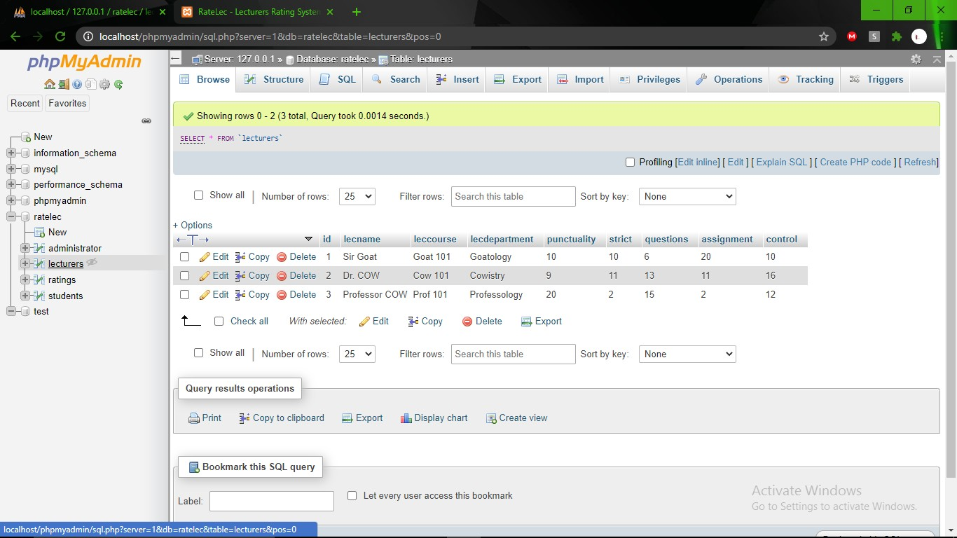

## Testing

How do you show that the functional and nonfunctional requirements have been met. Explain the testing approach and methodology employed to evaluate the system. Identify the types of tests conducted (unit tests, integration tests, performance tests, usability/user acceptance tests and system test). Describe the test environment and any test data or scenarios used.

## Figure 3

*Example of Testing result*

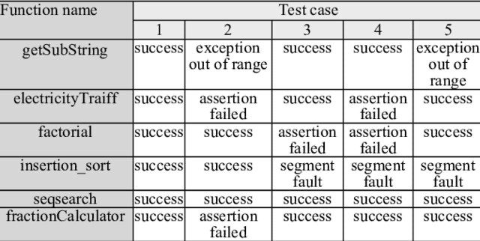

* + 1. Unit Testing

## Figure 4

*Example of Unit testing Result*

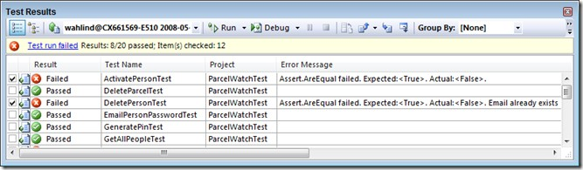

## Figure 5

*Testing Result*

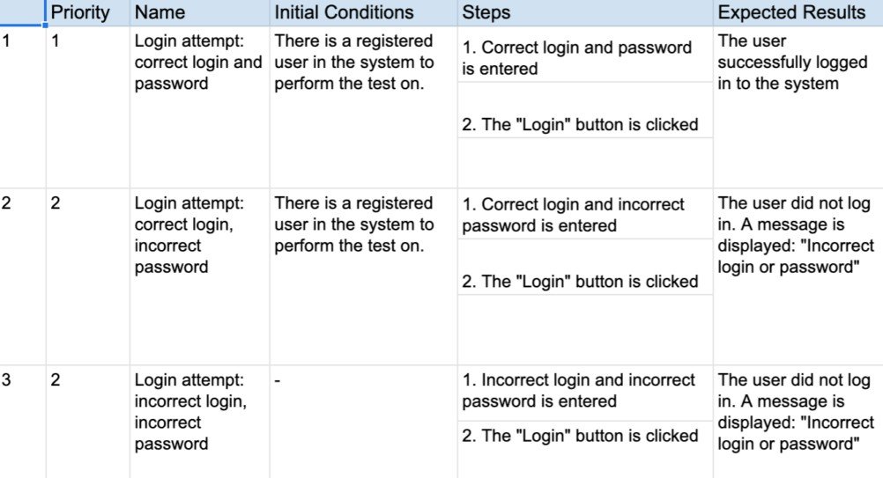

## Figure 6

*Usability Testing Result*

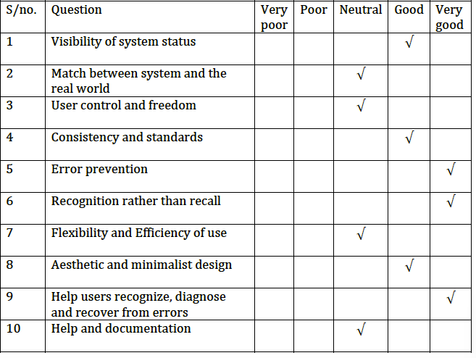

## Figure 7

*Results Presentation*

|  |  |  |  |  |  |
| --- | --- | --- | --- | --- | --- |
| **Models** | **Class** | **Precision** | **Recall** | **F1-score** | **Support** |
| **Random Forest** | Benign | 1.00 | 1.00 | 1.00 | 1915 |
| Lateral Movement | 0.75 | 0.82 | 0.78 | 22 |
| **Decision Tree** | Benign | 1.00 | 1.00 | 1.00 | 1905 |
| Lateral Movement | 0.87 | 0.84 | 0.86 | 32 |
| **KNN** | Benign | 0.99 | 1.00 | 1.00 | 1913 |
| Lateral  Movement | 0.68 | 0.54 | 0.60 | 24 |

## Figure 8

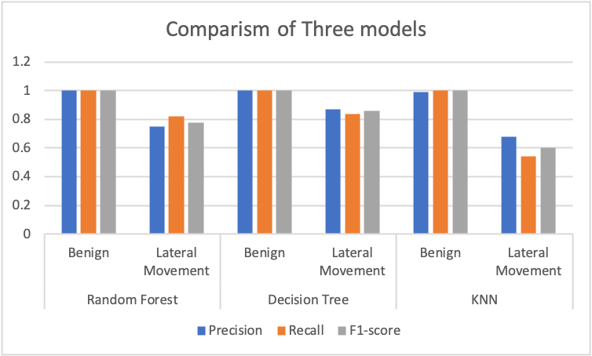*Evaluation of ML Results*

## Figure 6

*System Performance Evaluation*

|  |  |  |
| --- | --- | --- |
| **Author** | **Method** | **Accuracy** |
| Chandran et al. (2015) | Random Forest (Application plane) | 99.8% |
| Ghafir et al.(2018) | Machine Learning correlation analysis (Network plane) | 84.8% |
| Schindler (2018) | Support Vector Machine (Application Plane) | 98.6% |
| Adelaiye et al. (2021) | Improved Detection Model (Network plane) | 99.95% |

## Discussion

The Discussion presents explanations for the results obtained in the study. Comparison with existing information/earlier works on the subject should always be made. Justification for is agreements with earlier works should be made.

* + 1. Some projects require a discussion section
       1. Machine Learning Approaches
       2. Simulation Approach
    2. This is a section using paragraph format to;
       1. Present the results and relate them to the objectives
       2. Indicate relevance and effect
       3. Provide significance and how it has outperformed existing methods

# CHAPTER FIVE

**SUMMARY, CONCLUSION AND RECOMMENDATION**

## Summary

The summary should present highlights of the major findings while the conclusions give an inference drawn from the findings. Challenges encountered during the study should be indicated.

## Conclusion

Conclusions should be drawn on the basis of the data presented and analyzed, and policy

## Recommendation

Recommendations should be based on the major findings of the study and stated in precise terms. It should list possible ways of solving problems identified as well as highlight areas for further research.

# REFERENCES

## Book:

**Book with One Author:**

Author. (Year). *Title of the book.* Publisher.

Example: Adelaiye, O. I. (2019). *Attacker Persona in Cybercrime activities.* Bingham Press.

## Book with Two Authors:

Author1 & Author2. (Year). *Title of the book.* Publisher.

Example: Musa, Y. & Adelaiye, O. (2020). *Research writing in Computing.* Academic Press.

## Journal Article:

**Journal Article with One Author:**

Author. (Year). Title of the article. *Title of the Journal, Volume*(Issue), Page numbers. Example: Usman, A. (2018). Multi vector attack trends in communication industry. *Journal of Cybersecurity, 42*(3), 235-248.

## Journal Article with Two Authors:

Author1 & Author2. (Year). Title of the article. *Title of the Journal, Volume*(Issue), Page numbers.

Example: Hassan A. & Musa, Y. (2017). Effects of machine learning approaches on privacy.

*Journal of cybersecurity and data privacy, 24*(2), 135-148.

## Website:

**Webpage with Author:**

Author. (Year, Month Day). Title of the webpage. Website Name. URL

Example: Faki, A. (2021, June 15). How to write an effective research paper. APA Style Blog. https://blog.apastyle.org/apastyle/2021/06/how-to-write-an-effective-research-paper.html **Webpage without Author:**

Title of the webpage. (Year, Month Day). Website Name. URL

Example: APA Citation Style Guide. (2020, November 10). Purdue OWL. https://owl.purdue.edu/owl/research_and_citation/apa_style/apa_formatting_and_style_guide

/general_format.html

## Report:

**Government Report:**

Government Agency. (Year). *Title of the Report* (Report No. if available). Publisher.

Example: U.S. Department of Health and Human Services. (2019). *National Health Statistics Report, No. 42*. National Center for Health Statistics.

## Technical Report:

Author. (Year). *Title of the Report* (Report No. if available). Publisher.

Example: Musa, Y. P. (2022). *Cybersecurity Threat Landscape Report* (Report No. 56789). Symantec Corporation.

## Conference Paper:

**Conference Paper with DOI:**

Author. (Year). Title of the paper. In *Title of the Proceedings* (pp. Page numbers). Conference Name. DOI

Example: Onu, E. (2018). Security measures in online banking. In *Proceedings of the International Conference on Cybersecurity* (pp. 45-58). ACM. https://doi.org/10.1145/12345 **Conference Paper without DOI:**

Author. (Year). Title of the paper. In *Title of the Proceedings* (pp. Page numbers). Conference Name.

Example: Adelaiye, O. (2017). Artificial intelligence in healthcare. In *Proceedings of the Annual Conference on Health Informatics* (pp. 78-91). HealthInfo.

## Thesis/Dissertation:

**Doctoral Dissertation:**

Author. (Year). *Title of the dissertation* (Doctoral dissertation). University Name.

Example: Musa, Y. P. (2016). *The Impact of Social Media on Consumer Behavior* (Doctoral dissertation). University of California, Los Angeles.

## Master's Thesis:

Author. (Year). *Title of the thesis* (Master's thesis). University Name.

Example: Adelaiye, O. I. (2019). *Evaluating the Efficacy of Online Learning Platforms*

(Master's thesis). Stanford University.

## Social Media Post:

**Social Media Post (Twitter):**

Author. (Year, Month Day). *Text of the tweet* [Tweet]. Twitter. URL

Example: @APA_Style. (2020, July 20). APA Style introduces 7th edition. https://twitter.com/APA_Style/status/1285308041014590977

## Social Media Post (Facebook/Instagram):

Author. (Year, Month Day). *Text of the post* [Post]. Facebook/Instagram. URL (if applicable) Example: American Psychological Association. (2021, May 10). Check out our latest blog post on mental health during the pandemic [Post]. Facebook. https://[www.facebook.com/APA/posts/10158325678926279](http://www.facebook.com/APA/posts/10158325678926279)

# APPENDIX A

Each Appendix should be identified with a letter (A, B, C, …).

The following list of documents must be included as appendices: • Project Proposal including your original plan

* First Progress Review Report
* code/artefact
* Any other document of importance for validation of work don